Pokhara University

Level: Bachelor | Semester – Fall | Year : 2009
Programme: BE |  | Full Marks : 100
Course: Applied Mechanics (Statics) |  | Time : 3hrs.

Candidates are required to give their answers in their own words as far as practicable.
The figures in the margin indicate full marks.

Attempt all the questions.

1. | Resolve any force in its three rectangular components with magnitude and direction. Determine the resultant of the two forces shown. | 15
2. | Describe angle of friction with suitable example and neat sketch. A block A weighing 500N rests on a block B weighing 700N which rests on an inclined plane incline at 30⁰ to the horizontal as shown in fig. Find what minimum force P parallel to the plane is required on the block B so as to drag it down the slope. (take coefficient of friction is 0.2) | 15
3. | - Determine the moment of inertial of any rectangle by method of integration.  - Locate the cenroid given figure. | 8  7
4. | Describe free body diagram with example. The cylinders A and B weigh 1000N and 2000N. It is given that radius of A and B is 0.60m and radius of B is 1.2m. Determine the forces exerted at the contact points. | 15
5. | Analysis the given truss by method of joints.  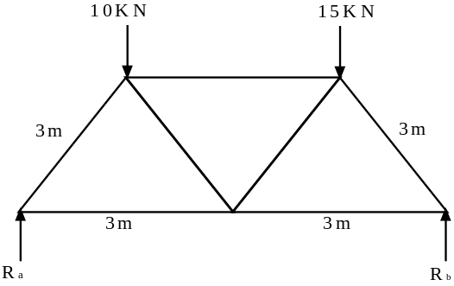 | 15
6. | Draw shear fore and bending moment diagram of given beam.  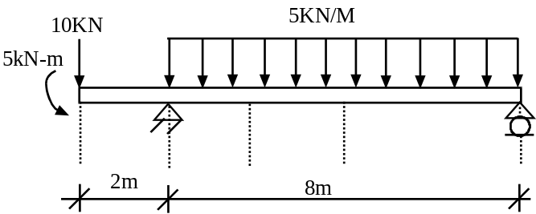 | 15
7. | Write short notes on (Any Two)  - Radius of gyration  - Determinancy and stability of structure  - Relation between shear force and bending moment. | 5×2

